Chapter 19, Problem 31.

Determine the hybrid parameters for the network in Fig.19.89.

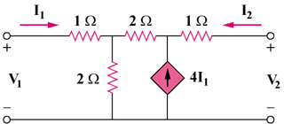

Figure 19.89
For Prob. 1931.

